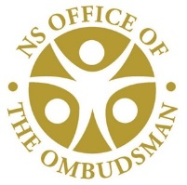

5657 Spring Garden Road, Suite 200
Halifax, Nova Scotia
B3J 3R4
Office of the Ombudsman
Nova Scotia

Ombudsman Expense Report

William A. Smith, Ombudsman
October 1, 2021 to December 31, 2021

Travel

Expenses reported include travel in relation to the Ombudsman’s duties and responsibilities, including any provision of hospitality. This report does not include expenses related to confidential investigative files.

* “Other Transportation” includes car rentals, mileage, parking, bus, taxis, etc. while on travel status.
** “Other” includes incidentals such as long distance phone calls, etc. while on travel status.

Travel Dates | Rationale – Destination | Airfare | Other Transportation* | Accommodation | Meals | Other** | Total
October 20, 2021 | Meeting |  |  |  |  | $2.34 | $2.34
November 25, 2021 | Meeting in Port Williams |  | $83.07 |  | $15.00 |  | 98.07
December 15, 2021 | Meeting in Sydney |  | 395.97 | 171.56 | 50.00 | 13.05 | $630.58

Hospitality and Staff Meals

Date | Description / Rationale | Amount
n/a | n/a | n/a

$730.99
Cumulative total for October 1, 2021 to December 31, 2021

